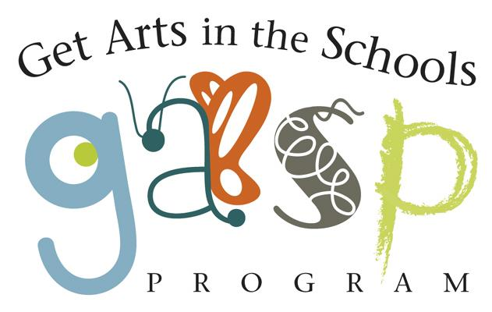

Please see the Grant Guidelines for Artists for complete application instructions and program requirements.
Important Dates & Deadlines

Artist Applications Due | Rolling
School Teacher Request Forms Due | With application
Panel Review & Artist Selection | Rolling
Panel Review & School Selection | Rolling
Award Notification | Grant awards will be made until funds are depleted.
Program Period | October 2022-June 2023
Evaluations and Payment Request Forms Due | June 9, 2023
*Please note: The form that follows is only one element of a complete application packet.

To apply for a GASP grant, an artist must submit all of the following elements:
- Artist Application Form (this form)
- Project Summary (up to two pages)
- Teacher Request Form (LINK HERE)

ONLY New applicants should also submit the following:
- Artist Resumé or Bio (up to two pages)
- References (two professional references)
- Artistic Support Materials (up to six samples)

Artist Name: _____________________________________________________________
Address: _________________________________________________________________
City: _________________________________ State: _____ Zip: _________________
Phone: ____________________________ Email (required): ________________________
Website: __________________________
Name of Proposed GASP Project: _____________________________________________
Project Details:

Artistic Discipline(s): _______________________________________________________

Current member of the Arts Council of Mendocino County: ____ yes ____ no

Do you have a preferred school / teacher? Name: _____________________________________
Please attach the completed teacher’s request form to this application.

How many students will this project serve?___________
How many classrooms will this project serve?_________

Project Summary (2-3 sentences):

**Please attach the full Project Description (up to 2 pages) in a separate document.

What type of project is this? Please check one:
- Performance (must fit into a 45–60 minute time frame)

- Classroom Sessions (one to four 45–60 minute classes per day per school; can include multiple days/weeks; each class meets with the artist for one class period)

- Residency Program (multiple encounters with the same group of students; program should be a minimum of 3 and a maximum of 30 sessions long). In rare cases extended residencies are funded if pre-approved, and if school or artist has additional funding outside of GASP funds.
Project Budget

Artist Fee | Prep Time Fee | Materials Fee | Travel Stipend  (If travel is in excess of 80 miles RT) | Total Grant
*feel free to add additional rows as needed

Materials description -please describe any materials that the grant will purchase below:

Total Grant Request: $
Value and description of any in kind contributions or matching funds: $
I/We have worked within a classroom environment with school children in K-12 grades. I/We do hereby certify that I/we am/are residents of Mendocino County, and that all figures, facts and representations made in this application, including all exhibits and attachments made a part of this application, are true and correct to the best of my/our knowledge and belief.

Print Name: ______________________________________________________________
Signature: _________________________________________ Date: ___________________
By signing this application, the signatory agrees to permit the Arts Council of Mendocino County and Mendocino County Office of Education to use photographs and images made of this project and public activities connected with this project for ACMC and MCOE press releases and publications.

