Recycled Fashion: A Global Cultural Perspective—Using existing goods to create clothing and other household items is currently in vogue, yet it is far from new. Secondhand fashion has a history as old as the production of clothing itself, with recorded evidence dating as far back as Plato in 400 BC. Humans are resourceful, so when resources grow scarce, humans adapt—whether in ancient Greece or modern day Africa.

Used clothes represent the largest numbers of existing garments but until recently they were not perceived as serious fashion items. However, this has changed dramatically with the rise of vintage web sites, value clothing chains, and the fashion media's perpetuation of the idea that secondhand clothes can be recycled into avant-garde "cool". The Japanese, for example, have been salvaging sections of kimonos for centuries and in India garments are inexhaustibly recycled. In 1813, English textile maker Benjamin Law developed the process of taking old clothes and grinding them down into a fibrous state, which was then spun into yarn and sold as shoddy and mungo wool.

Today, many places on the planet, especially its poorer regions, are being buried under the waste of the global production process. Plastic bottles litter streets and clog valuable waterways. Yet resourceful people are embracing the pollution that plagues their environment by innovating new ways of re-using plastics, discarded metal, old tires, newspapers, rags, food containers and other waste products into beautiful “fabrics.” Whether sewn, woven or beaded, many such “third world” items are finding their way into “fair trade” stores and other eco-fashion outlets—thus providing income to communities that need it the most.

Today, the world traveler will find a large variety of innovative recycled fashion items, from purses made from bottle caps, pull tabs, gum wrappers and newspapers, to recycled bottle fabric and telephone wire jewelry. Plastic bottles can be recycled into eco-fabric; candy wrappers can be woven to make textile-fabrics; magazines can be made into beads; plastic bags can be knitted; and on and on. The following images offer a cross-cultural and historical perspective into the innovative use of secondhand dress and age-old global traditions of recycling fashion.

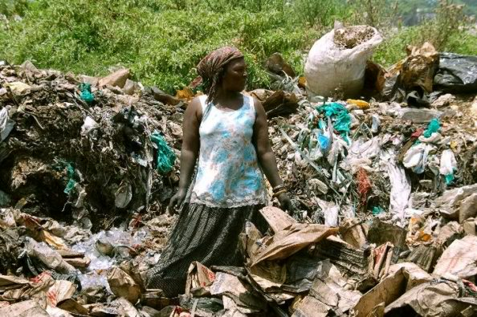 | Africa: Woman collecting plastic to use for bags.
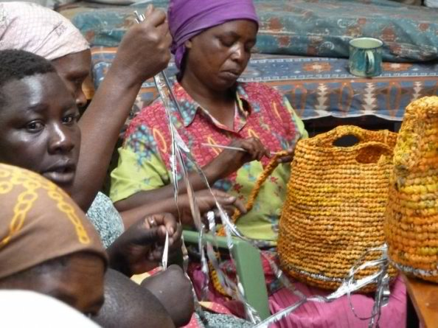 | Africa: Women crocheting bags out of discarded plastics.
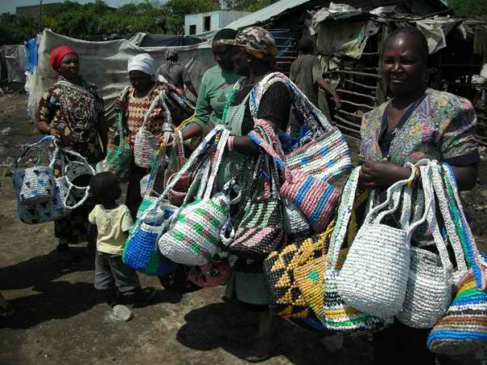 | Africa: Women selling their finished bags on the streets.
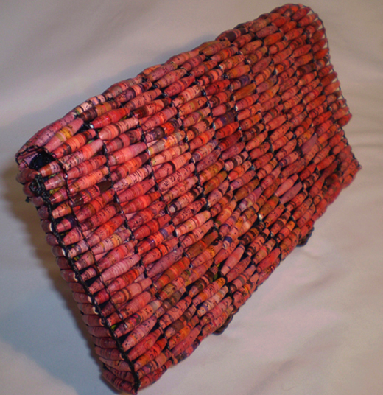 | Africa: Purse made from recycled paper beads.
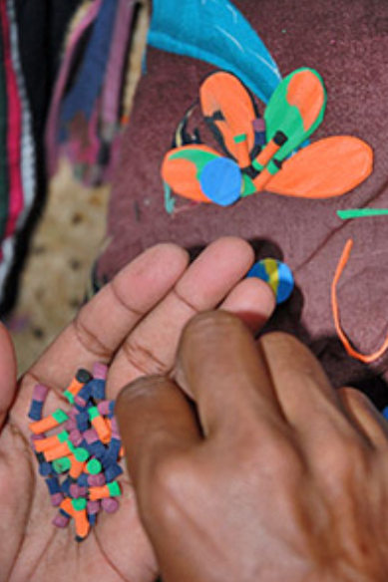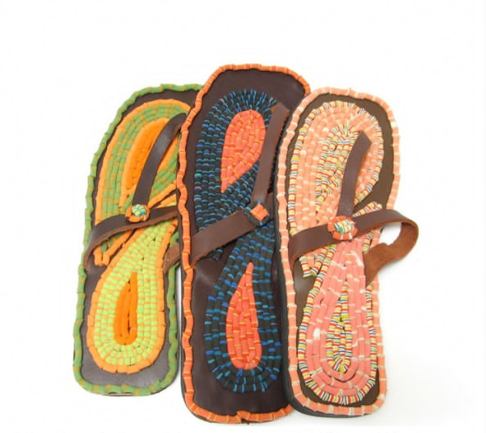 | Africa: Recycled plastic bottle flip flops.
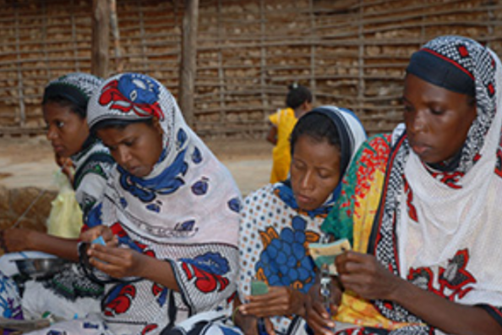 | Africa: Women turning recycled plastic bottles into flip flops.
 | Mexico: Bottle top purse.
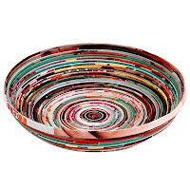 | Vietnam: Recycled newspaper coiled into a bowl/basket.
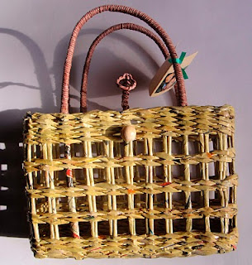 | Uganda: Discarded telephone directories woven into basket bags.
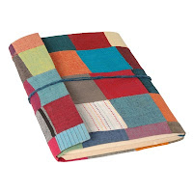 | Nepal: Recycled Sari pamphlet style coin purse.
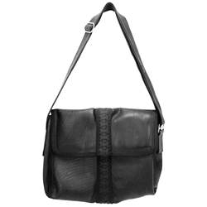 | India: Messenger bag made from old inner tubes and bike tires.
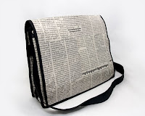 | Cambodia: Recycled newspaper messenger bag.
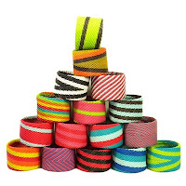 | South Africa: Recycled telephone wire bangles.
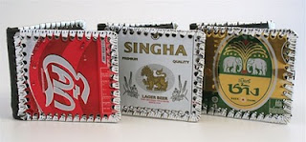 | Thailand: Recycled Singh, Change and Coke can wallets.
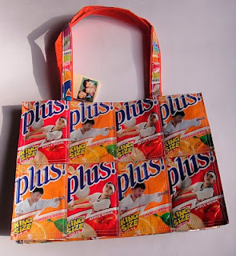 | Philippines: Discarded juice cartons stitched together into tote shopper bags by women’s co-op.
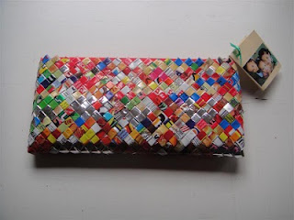 | Philippines: Chip packets woven together to make clutch, hand bags and purses by women’s co-op.

